
SRM Institute of Science and Technology
Mode of Exam
OFFLINE-SET C
College of Engineering and Technology
School of Computing
DEPARTMENT OF COMPUTING TECHNOLOGIES
SRM Nagar, Kattankulathur – 603203, Chengalpattu District, Tamilnadu
Academic Year: 2022-2023 (ODD/EVEN): ODD
Test: CLAT-2 Date: 14-10-2022
Course Code & Title: 18CSE356T - DOS Duration: 1 Hour
Year & Sem: III & V Max. Marks: 50

Course Articulation Matrix: (to be placed)
Part – A
( 20 x 1 = 20 Marks)
Instructions: Answer all
Q. No | Question | Marks | BL | CO | PO | PI Code
1. | The ________ layer provides dialog control to keep track of which party is currently talking.  - Application  - Presentation  - Session (A)  - Transport | 1 | 1 | 2 | 2 | 1.6.1*
2. | The session layer is responsible for ________  - Concerned with the meaning of bits in the message  - Notifies receiver that message contains a particular record in a certain format  - Provides dialog control and synchronization facilities (A)  - Detects and corrects data transmission errors | 1 | 1 | 2 | 2 | 1.6.1*
3. | Which of the following is not about TCP?  a) Connection-oriented  b) Process-to-process communication  c) Transport layer protocol  d) Unreliable service (A) | 1 | 2 | 2 | 2 | 1.6.1*
4. | The client server model has _______ levels of protocols  - Three (A)  - Two  - Five  - Four | 1 | 2 | 2 | 2 | 1.6.1*
5. | The packet type that is used by the client to probe to see if the server has crashed  - AYA  - IAA  - ACK  - TA | 1 | 1 | 2 | 2 | 1.6.1*
6. | Which type of parameter passing is preferable in RPC  - Call-by-reference  - Call-by-value  - Call by address | 1 | 1 | 2 | 2 | 1.6.1*
7. | For a server to deregister with the binder, what are the necessary inputs given by the server?  - Name, version  - Name, version, unique id  - Name , Version, Handle, unique id  - Name , services | 1 | 2 | 2 | 2 | 1.6.1*
8. | In remote procedure call, the client program must be bound with a small library procedure called ...................  - Server stub  - Marshalling  - Client hub  - Client stub (A) | 1 | 2 | 2 | 2 | 1.6.1*
9. | The ______ is an example of connectionless transport layer protocol  - UDP (A)  - TCP  - X.25  - IP | 1 | 2 | 2 | 2 | 1.6.1*
10. | In machine. Process addressing used by client–server model, 243.4 or 4@243 denotes ____________.  - Process 4 on machine 243 (A)  - Process 243 on machine 4  - Process 4 on machine 243.4  - Process 4 on machine 243.4 | 1 | 2 | 2 | 2 | 1.6.1*
11. | When the server receives the AYA packet and it is still alive, its reply packet is ___________.  - UA  - IAA (A)  - ACK  - TA | 1 | 2 | 2 | 2 | 1.6.1*
12. | A _________is a piece of code that translates parameters sent between the client and server during a remote procedure call in distributed computing.  - Stub (A)  - Skeleton  - Orphan  - Zombies | 1 | 2 | 2 | 2 | 1.6.1*
13. | Before a client stub sends an RPC message, it makes a log entry telling what it is about to do. After a reboot, the log is checked and the orphan is explicitly killed off.  - Extermination (A)  - Reincarnation  - Gentle reincarnation  - Expiration | 1 | 2 | 2 | 2 | 1.6.1*
14. | In client server model the SEND and RECEIVE primitives are called as ................. primitives.  a. blocking  b. non-blocking  c. data transfer(A)  d. error control | 1 | 2 | 2 | 2 | 1.6.1*
15. | In Passive Time Server Centralized Algorithm, when the reply is received at the client's node, its clock is readjusted to  - T1+(T1 – T0)/2  - T0+(T2 – T1)/2  - T2+(T1 – T0)/2  - T+(T1 – T0)/2 (A) | 1 | 2 | 3 | 3 | 1.6.1*
16. | In Cristian’s algorithm, the time server is active.  - True (A)  - False | 1 | 2 | 3 | 3 | 1.6.1*
17. | If timestamps of two events are same, then the events are ____________  a) concurrent (A)  b) non-concurrent  c) monotonic  d) non-monotonic | 1 | 2 | 3 | 3 | 1.6.1*
18 | Number of messages required in Ricart Agrawala Algorithm is?  - 2(N-1) (A)  - 3(N-1)  - 3(N+1)  - 2(N²-1) | 1 | 2 | 3 | 3 | 1.6.1*
19 | A clock is said to be non-faulty if the following condition holds:  a. 1+ρ ≤ dc/dt ≥ 1-ρ  b. 1-ρ ≤ dc/dt ≥ 1+ρ  c. 1+ρ ≥ dc/dt ≤ 1-ρ  d. 1+ρ ≤ dc/dt ≥ ρ 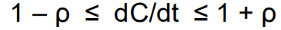(A) | 1 | 2 | 3 | 3 | 1.6.1*
20 | In Computer Clocks _____________is used to keep track of the oscillations of the quartz crystal.  - Constant Register  - Counter Register (A)  - Clock tick  - Drift Rate | 1 | 2 | 3 | 3 | 1.6.1*
Part – B
( 3 x 10 = 30 Marks)

21 a | Explain the OSI reference model with neat diagram with responsibilities and functionalities of each layer.  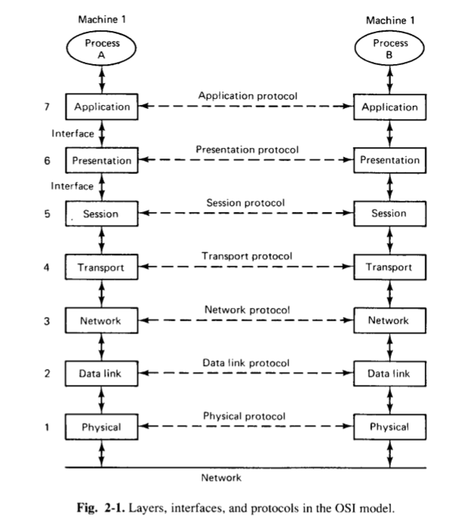 | 10 | 3 | 2 | 2 | 1.6.1*
OR
21 b | Illustrate about the Client Server Protocol Stack and various addressing modes available for the client to know the servers’ address.  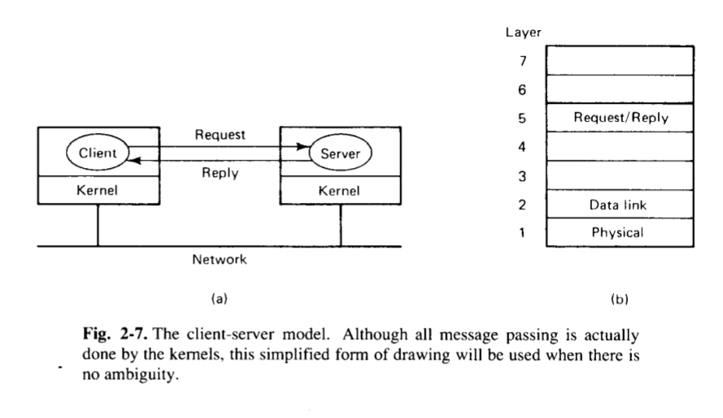  - For a client to send a message to a server - Must know the server's address.  - File server has been assigned a numerical address (243), but - Not really specified what this means.  - If only one process on destination machine, the kernel will give it to the one and only process running there.  - Alternative addressing system: [machine.process addressing]  - Process addressing with broadcasting  To assign each process a unique address that does not contain an embedded machine number. | 10 | 3 | 2 | 2 | 1.6.1*
22 a | Discuss on the following design issues of client –server implementation.  - Blocking vs non-blocking primitives  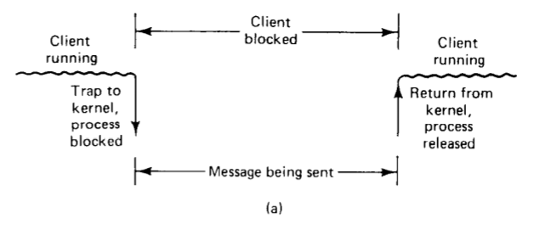  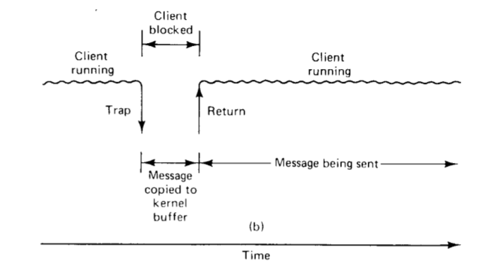  - Reliable vs Unreliable primitives.  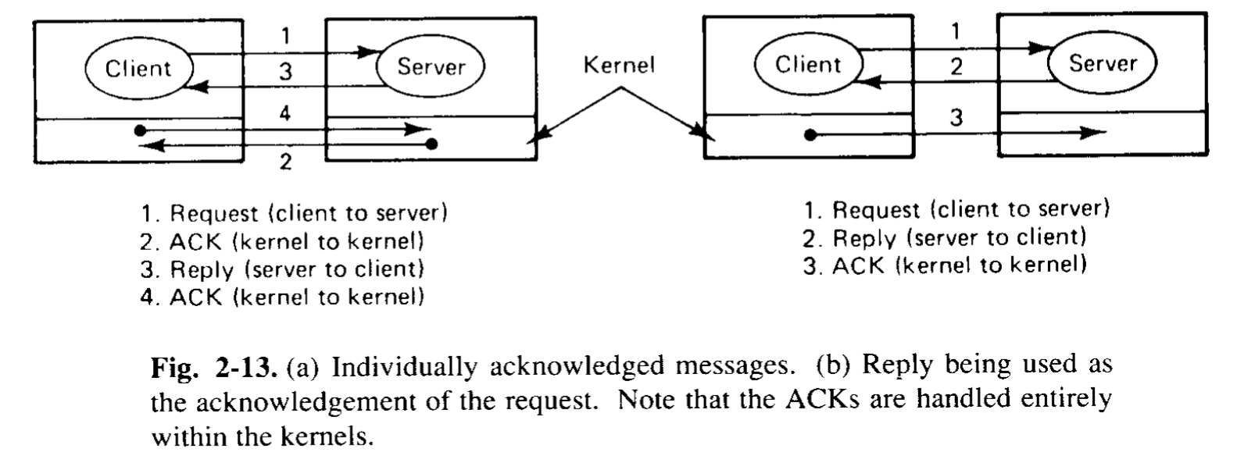 | 10 | 4 | 2 | 2 | 1.6.1*
OR
22 b | Explain the RPC mechanism and discuss the RPC semantics in presence of client Crash and loss of reply messages. | 10 | 4 | 2 | 2 | 1.6.1*
23 a | State the need of clock synchronization in distributed systems? Brief about the following Clock synchronization algorithms with an example.  Cristian Algorithm  - Method 2: Assumes that no additional information is available.  - Proposed by Cristian [1989].  - Several measurements of T1 – T0 are made.  - Measurements exceeding some threshold value - Discarded.  - The average of the remaining measurements is then calculated, and half of the calculated value is used as the value to be added to T.  - Alternatively, minimum T1- T0 taken as most accurate one, and half of this value is used as the value to be added to T.  Berkeley Algorithm  - Proposed by Gusella and Zatti [1989] for internal synchronization of clocks of a group of computers running the Berkeley UNIX.  - Time server periodically sends a message ("time = ?") to all the computers in the group.  - Time server has a priori knowledge of the approximate time required for the propagation of a message from each node to its own node.  - Based on this knowledge, it first readjusts the clock values of the reply messages.  - Takes fault-tolerant average of the clock values of all the computers (including its own) - the time server chooses a subset of all clock values that do not differ from one another by more than a specified amount, and the average is taken only for the clock values in this subset. | 10 | 3 | 3 | 3 | 1.6.1*
OR
23 b | How mutual exclusion can happen in Distributed systems? Explain any two mutual exclusion algorithms in distributed systems.  - The sections of a program that need exclusive access to shared resources are referred to as critical sections.  - For mutual exclusion , Ways are introduced, to prevent processes from executing concurrently with their associated critical section.  Following requirement must satisfy for mutual exclusion:  - Mutual exclusion: At anytime only one process should access the resource. A process can get another resource first releasing its own.  - No starvation: if every process that is granted the resource eventually release it, every request must be eventually granted.  Centralized Algorithm  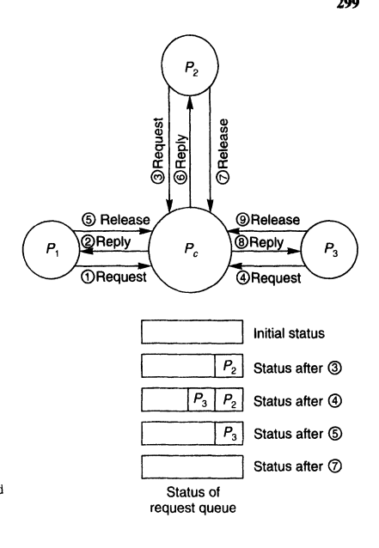  Token Ring  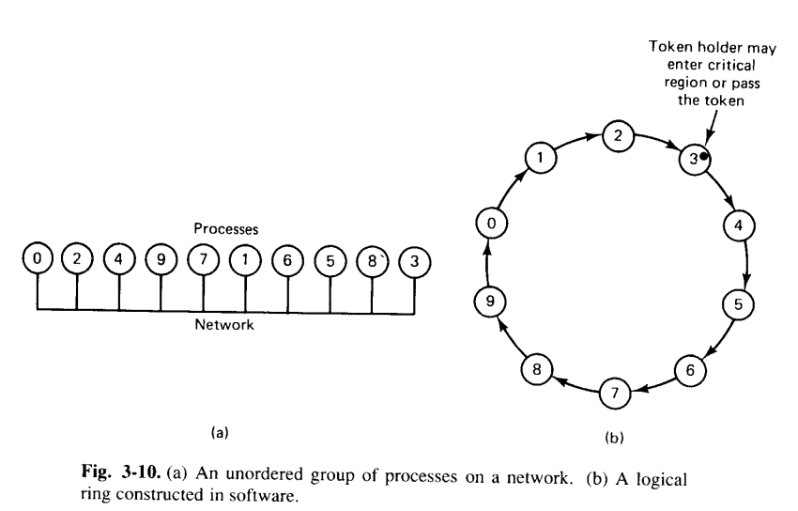 | 10 | 4 | 3 | 3 | 1.6.1*

*Performance Indicators are available separately for Computer Science and Engineering in AICTE examination reforms policy.

Course Outcome (CO) and Bloom’s level (BL) Coverage in Questions

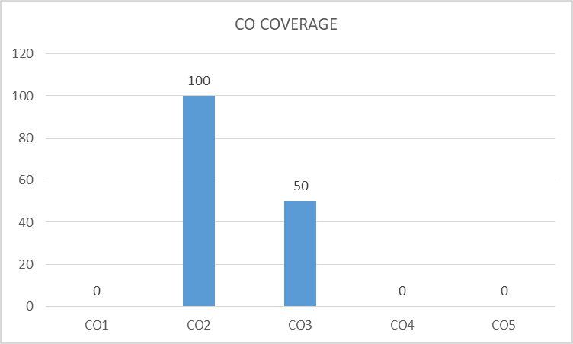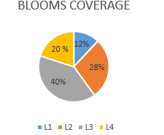
Dr.Jagadeesan.S 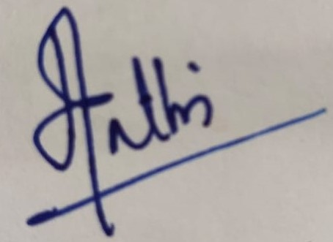

Prepared By Approved by the Audit Professor/Course Coordinator

